**New drug lead compound discovery against diabetic peripheral neuropathy**

Xx Xx, Xx Xx, Xx Xx, Xx Xx

School of Medicine, Nanjing University of Chinese Medicine

（≤300字/Words）Diabetic peripheral neuropathy (DPN) Diabetic peripheral neuropathy (DPN) Diabetic peripheral neuropathy (DPN) Diabetic peripheral neuropathy (DPN) Diabetic peripheral neuropathy (DPN) Diabetic peripheral neuropathy (DPN) Diabetic peripheral neuropathy (DPN) Diabetic peripheral neuropathy (DPN) Diabetic peripheral neuropathy (DPN) Diabetic peripheral neuropathy (DPN) Diabetic peripheral neuropathy (DPN) Diabetic peripheral neuropathy (DPN) Diabetic peripheral neuropathy (DPN) Diabetic peripheral neuropathy (DPN) Diabetic peripheral neuropathy (DPN) Diabetic peripheral neuropathy (DPN) Diabetic peripheral neuropathy (DPN) Diabetic peripheral neuropathy (DPN) Diabetic peripheral neuropathy (DPN) Diabetic peripheral neuropathy (DPN) Diabetic peripheral neuropathy (DPN) Diabetic peripheral neuropathy (DPN) Diabetic peripheral neuropathy (DPN) Diabetic peripheral neuropathy (DPN) Diabetic peripheral neuropathy (DPN) Diabetic peripheral neuropathy (DPN) Diabetic peripheral neuropathy (DPN) Diabetic peripheral neuropathy (DPN) Diabetic peripheral neuropathy (DPN) Diabetic peripheral neuropathy (DPN) Diabetic peripheral neuropathy (DPN) Diabetic peripheral neuropathy (DPN).

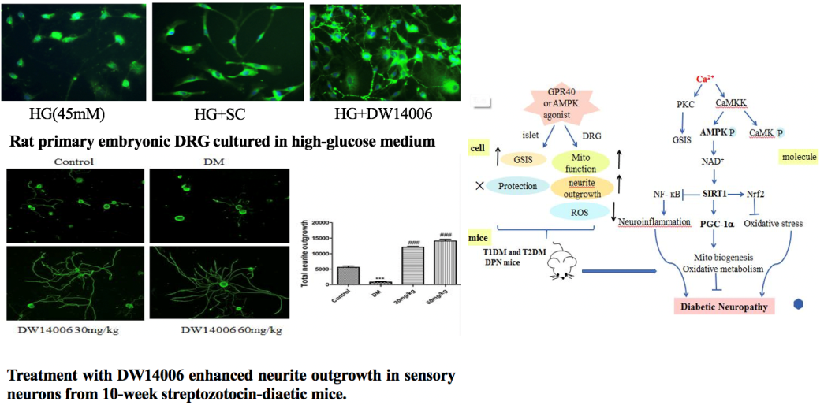

【资助项目】国家自然科学基金（No.xxxx），…..。

照

片

通讯作者简介：中英文均可，字数≤100字/words

邮箱：